T-Shirt Printing Company

Database Design Project

2020

Topic: A printing company (or a T-Shirt printing company)

|  |  |
| --- | --- |
| Group member | |
| Name | Account |
| Alex Jonathan Mvami Njeunje | AJMN100 (Primary: Data Created and Stored here) |
| Sakala Lakshmi Venkata Maurya | LVMS100 |

# Table of Contents

Table of Contents 2

A. Describe the enterprise 3

1. Introduction 3

2. System Main Functionality 3

3. End Users 3

4. Data Obsolescence 3

5. Project Idea 3

B. Entity Relationship Design 4

1. Entity Listing and Description 4

2. Relationships 6

3. E-R Diagram 7

C. Conceptual Level 8

D. External View 10

E. Internal View 10

1. Frequent Queries 10

a. File structure implemented 15

2. More commands 15

F. Data Dictionary 16

# Describe the enterprise

## Introduction

This project deals about the t-shit printing company which contains information of employees and customers. It keeps track of orders given by customers and employee creates the printing profile of orders from the T-Shirts available in the inventory. We also have the materials that we use to print the T-Shirts. We also deals with the billing stuff like T-shirt cost to print and total order cost to print the t-shirts. Employee will be the in charge to keep track of the printing jobs.

## System Main Functionality

The system will perform the following and more:

* Show all the pending, done, and cancelled orders from a customer.
* Show all the pending orders with related printing jobs, ordered by their estimated delivery date.
* Show all the overdue orders.
* Show all the available T-shirts.
* Show all the printing profiles.
* Create a new order
* Create a new printing profile
* Update a printing profile price
* Delete all canceled orders
* Delete all incomplete orders

## End Users

In our project Employees and Customers acts as end users.

## Data Obsolescence

In our project we are handling data obsolescence by deleting the unwanted records in the tables.

## Project Idea

We got the suggestion from the professor.

# Entity Relationship Design

## Entity Listing and Description

|  |  |  |  |
| --- | --- | --- | --- |
| # | Entity Name | Attributes | Entity Description |
| 1 | Customers | * cusEmail: (Unique) customer email. Used by: Customer, Employee * cusName: customer name. Used by: Customer, Employee * cusPhone#: customer phone number. Used by: Customer, Employee | This table gives information of customers |
| 2 | Employees | * empEmail: (Unique) employee email. Used by: Customer, Employee * empName: emp name. Used by: Customer, Employee * empPhone#: emp phone number. Used by: Customer, Employee | This table gives information of employees |
| 3 | PrintingProfiles | * proName: (Unique) . Used by: Customer, Employee * proMode: {B&W, Colored}. Used by: Customer, Employee * proSize: {Small, Medium, Large}. Used by: Customer, Employee * proPosition: {Front, Back, Sleeves}. Used by: Customer, Employee * proDescription: . Used by: Customer, Employee * proEstTime: Estimated time needed for one print of the printing profile. Used by: Customer, Employee * proPrice: Employee estimated price for the printing profile. Used by: Customer, Employee | This table gives information of printing profiles created by employees |
| 4 | PrintingJobs | * jobQuantity: Number of prints for this job. . Used by: Customer, Employee * jobUnitPrice: (derived). {= tshPrice + proPrice}.. Used by: Customer, Employee * jobTotalCost: (derived). {= jobUnitCost*jobQuantity}.. Used by: Customer, Employee * jobEstTime: (Derived). {= proEstTime*jobQuantity}. Used by: Customer, Employee * jobInstructions: Additional instruction from customer. . Used by: Customer, Employee | This table gives information of printing job of printing profiles.  Is a weak entity |
| 5 | ArtWorks | * artName: (Unique) . Used by: Customer, Employee * artImage: Name of image file provided by the customer. Used by: Customer, Employee | This table gives information of artwork of T-Shirts |
| 6 | PrintingMaterials | * matProduct#: (unique) . Used by: Customer, Employee. Used by: Customer, Employee * matName: [e.x. Red ink…] * matAmount: (Dynamic) . Used by: Customer, Employee | This table gives information of materials used for printing |
| 7 | TShirts | * tshBrand: . Used by: Customer, Employee * tshName: . Used by: Customer, Employee * tshColor: . Used by: Customer, Employee * tshSize: {x-small, small, medium, large, x-large}. Used by: Customer, Employee * tshAmount: . Used by: Customer, Employee * tshPrice: . Used by: Customer, Employee | This table gives information of T-Shirts available |

## Relationships

|  |  |  |  |
| --- | --- | --- | --- |
| # | Relationship | Entities Related | Description |
| 1 | Orders | Customer to Employee | * A Customer make Orders to many Employees. * An Employee can take Orders from many Customers. |
| 2 | PartOf | Printing Job to Order | * A Printing Job can be part of a single order. * An Order can be can have many Printing Jobs. |
| 3 | Create | Employee to Printing Profile | * An Employee Can Create many Printing Profiles. * A Printing Profile can be Created by a Single Employee. |
| 4 | Owns | Customer to Artwork | * A Customer Owns many Artworks. * An Artwork can be owned by a single Customer. |
| 5 | Include | Artwork to Printing Job | * An Artwork can be included in many Printing Jobs. * A Printing Job can include a Single Artwork. |
| 6 | TakesIn | T-Shirt to Printing Job | * A T-Shirt is taken for many Printing Jobs. * A Printing Job takes in a T-Shirt. |
| 7 | ConsistsOf | Printing Profile to Printing Job | * A Printing Profile constitutes many Printing Jobs. * A Printing Job consists of a single Printing Profile. |
| 8 | Uses | Printing Material to Printing Profile | * A Printing Material is used for many Printing Profiles. * A Printing Profile uses many Printing Material. |

## E-R Diagram

The resulting ER diagram:

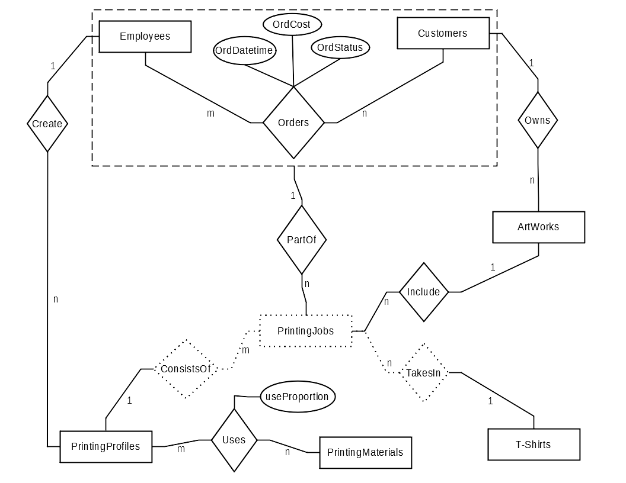

# Conceptual Level

* **Primary Keys in bold**
* Foreign Keys in underlined

|  |  |  |  |  |
| --- | --- | --- | --- | --- |
| # | Table Name | Properties/Columns | Functional Dependencies | Comments |
| 1 | Customers | * **cusEmail** * cusName * cusPhone# | cusEmail 🡪 cusName, cusPhone# |  |
| 2 | Employees | * **empEmail** * empName * empPhone# | empEmail 🡪 empName, empPhone# |  |
| 3 | PrintingProfiles | * **proName** * proMode * proSize * proPosition * proDescription * proEstTime * proPrice * empEmail | proName 🡪 proMode, proSize, proPosition, proDescriotion, proEstTime, proPrice |  |
| 4 | PrintingJobs | * jobQuantity * jobUnitPrice * jobTotalCost * jobInstructions * jobEstTime * **proName** * **tshBrand** * **tshName** * **tshColor** * **tshSize** * **ordID** * artName | proName, tshBrand, tshName, tshColor, tshSize, ordID 🡪 jobQuantity, jobUnitPrice, jobTotalCost, jobInstructions, jobEstTime |  |
| 5 | Artworks | * **artName** * artImage * cusEmail | artName 🡪 artImage |  |
| 6 | PrintingMaterials | * **matProduct#** * matName * matAmount | matProduct# 🡪 matName, matAmount |  |
| 7 | Tshirts | * **tshBrand** * **tshName** * **tshColor** * **tshSize** * tshAmount * tshPrice | tshBrand, tshName, tshColor, tshSize 🡪 tshAmount, tshPrice |  |
| 8 | Orders | * **ordID**: (auto generated starting with 1) * ordDatetime * ordCost * ordStatus: {Pending, Done, Delivered, Cancelled} * ordEstDeliveryDate * empEmail * cusEmail | ordID 🡪 ordDateTime, ordCost, ordStatus, ordEstDeliveryDate | This table gives information of orders given by customers |
| 9 | Use | * useProportion * **proName** * **matProduct#** | proName, matProduct# 🡪 useProportion | This table gives information of proportion of materials used in the printing profile |

# External View

|  |  |  |
| --- | --- | --- |
| USERS  TABLES/VIEWS | Employee | Customer |
| CUSTOMERS | SELECT, INSERT, UPDATE | SELECT, INSERT, UPDATE |
| EMPLOYEES | SELECT, INSERT, UPDATE | NONE |
| PRINTINGPROFILES | INSERT, UPDATE | NONE |
| PRINTINGJOBS | INSERT, UPDATE | INSERT, UPDATE |
| ARTWORKS | SELECT | SELECT, INSERT, UPDATE |
| PRINTINGMATERIALS | SELECT, INSERT, UPDATE | NONE |
| TSHIRTS | INSERT, UPDATE | NONE |
| ORDERS | INSERT, UPDATE | INSERT, UPDATE |
| USES | INSERT, UPDATE | NONE |
| CUSTOMERORDERS | SELECT | SELECT |
| PENDINGORDERS | SELECT | NONE |
| PROFILESLIST | SELECT | SELECT |
| CUSTOMERPRODUCTHISTORY | NONE | SELECT |
| AVAILABLETSHIRTS | SELECT | SELECT |
| OVERDUEORDERS | SELECT | NONE |

[Create the users in the database]

# Internal View

## Frequent Queries

Each table Identifies a most frequent query, it’s optimization and file structure needed.

|  |  |
| --- | --- |
| Query 1 | What is the list of all pending, done, and caneled orders passed by a customer given the customer email? |
| User | Customer, Employee |
| SQL | CREATE VIEW customerorders  AS    (SELECT orders.orddatetime,            orders.ordestdeliverydate,            orders.ordstatus,            orders.ordtotalcost,            printingjobs.proname,            printingjobs.tshbrand,            printingjobs.tshname,            printingjobs.tshcolor,            printingjobs.tshsize,            printingjobs.artname,            printingjobs.jobinstructions,            orders.cusemail     FROM   orders            INNER JOIN printingjobs                    ON ( orders.ordid = printingjobs.ordid )); |
| Relational Algebra | π(orders.orddatetime,  orders.ordestdeliverydate,  orders.ordstatus,  orders.ordtotalcost,  printingjobs.proname,  printingjobs.tshbrand,  printingjobs.tshname,  printingjobs.tshcolor,  printingjobs.tshsize,  printingjobs.artname,  printingjobs.jobinstructions,  orders.cusemail) [orders ⋈[ orders.ordid = printingjobs.ordid ] printingjobs] |
| Optimization | Already optimal! |
| Candidate File Structures | * Build a Cluster File on ordID in PrintingJobs * Build a Cluster File on ordID in Orders |

|  |  |
| --- | --- |
| Query 2 | What are all the poending orders with related printing jobs, ordered by the estimated delivery date. |
| User | Employee |
| SQL | CREATE VIEW pendingorders  AS    (SELECT orders.ordid,            orders.ordestdeliverydate,            orders.ordtotalcost,            printingjobs.jobquantity,            printingjobs.jobinstructions,            printingjobs.proname,            printingjobs.tshbrand,            printingjobs.tshname,            printingjobs.tshsize,            printingjobs.tshcolor     FROM   orders            INNER JOIN printingjobs                    ON ( orders.ordid = printingjobs.ordid )     WHERE  orders.ordstatus LIKE 'pending'); |
| Relational Algebra | π(orders.ordid,  orders.ordestdeliverydate,  orders.ordtotalcost,  printingjobs.jobquantity,  printingjobs.jobinstructions,  printingjobs.proname,  printingjobs.tshbrand,  printingjobs.tshname,  printingjobs.tshsize,  printingjobs.tshcolor) σ(orders.ordstatus = 'pending') [orders ⋈[ orders.ordid = printingjobs.ordid ] printingjobs] |
| Optimization | π(orders.ordid,  orders.ordestdeliverydate,  orders.ordtotalcost,  printingjobs.jobquantity,  printingjobs.jobinstructions,  printingjobs.proname,  printingjobs.tshbrand,  printingjobs.tshname,  printingjobs.tshsize,  printingjobs.tshcolor) [σ(orders.ordstatus = 'pending')orders ⋈[ orders.ordid = printingjobs.ordid ] printingjobs] |
| Candidate File Structures | * Build a Secondary B-Tree on ordStatus in Orders |

|  |  |
| --- | --- |
| Query 3 | Provide the list of all overdue orders. |
| User | **Employee** |
| SQL | CREATE VIEW overdueorders  AS    (SELECT empemail,            orddatetime,            ordestdeliverydate,            ordtotalcost     FROM   orders     WHERE  ordestdeliverydate < sysdate); |
| Relational Algebra | π(empemail,  orddatetime,  ordestdeliverydate,  ordtotalcost) [σ(ordestdeliverydate < sysdate)orders] |
| Optimization | Already optimal! |
| Candidate File Structures | * Build a Cluster B-Tree in Orders |

|  |  |
| --- | --- |
| Query 4 | Provide the list of all the available t-shirts. |
| User | **Customer, Employee** |
| SQL | CREATE VIEW availabletshirts  AS    (SELECT tshbrand,            tshname,            tshcolor,            tshsize,            tshamount,            tshprice     FROM   tshirts     WHERE  tshamount <> 0); |
| Relational Algebra | π(tshbrand,  tshname,  tshcolor,  tshsize,  tshamount,  tshprice) [σ(tshamount <> 0)tshirts] |
| Optimization | Already Optimal! |
| Candidate File Structures | * Build a Cluster B-Tree in Tshirts |

|  |  |
| --- | --- |
| Query 5 | Provide the list of all profiles. |
| User | **Customer, Employee** |
| SQL | CREATE VIEW profileslist  AS    (SELECT proname,            promode,            prosize,            prodescription,            proprice     FROM   printingprofiles); |
| Relational Algebra | π(proname,  promode,  prosize,  prodescription,  proprice) [σ(tshamount <> 0)printingprofiles] |
| Optimization | Already optimal! |
| Candidate File Structures | * Leave default Secondary B-Tree indexing |

|  |  |
| --- | --- |
| Query 6 | What are the printing profiles and T-Shirts ever used by a Customers given the Customers email? |
| User | **Customer** |
| SQL | CREATE VIEW customerproducthistory  AS    (SELECT orders.cusemail,            printingprofiles.proname,            printingprofiles.proprice,            tshirts.tshbrand,            tshirts.tshname,            tshirts.tshsize,            tshirts.tshcolor,            tshirts.tshprice     FROM   printingjobs            INNER JOIN printingprofiles                    ON printingjobs.proname = printingprofiles.proname            INNER JOIN tshirts                    ON ( printingjobs.tshbrand = tshirts.tshbrand                         AND printingjobs.tshname = tshirts.tshname                         AND printingjobs.tshcolor = tshirts.tshcolor                         AND printingjobs.tshsize = tshirts.tshsize )            INNER JOIN orders                    ON ( orders.ordid = printingjobs.ordid )) |
| Relational Algebra | π(orders.cusemail,  printingprofiles.proname,  printingprofiles.proprice,  tshirts.tshbrand,  tshirts.tshname,  tshirts.tshsize,  tshirts.tshcolor,  tshirts.tshprice) [[[printingjobs⋈[ printingjobs.proname = printingprofiles.proname] printingprofiles] ⋈[ printingjobs.tshbrand = tshirts.tshbrand  /\ printingjobs.tshname = tshirts.tshname  /\ printingjobs.tshcolor = tshirts.tshcolor  /\ printingjobs.tshsize = tshirts.tshsize] printingprofiles] ⋈[ orders.ordid = printingjobs.ordid] orders] |
| Optimization | Already optimal! |
| Candidate File Structures | * Build a Cluster File on proName in PrintingJobs * Build a Cluster File on proName in PrintingProfiles |

### File structure implemented

Synopsis of the actual file structures that will be implemented:

* Build a Cluster B-Tree in Orders
* Build a Cluster B-Tree in Tshirts
* Build a Cluster File on proName in PrintingJobs
* Build a Cluster File on proName in PrintingProfiles
* Build a Secondary B-Tree on ordStatus in Orders

## More commands

The following is a list of some other implemented commands:

1. Update: Update a printing profile.
2. Delete: Delete all canceled orders
3. Insert: Create a new order
4. Insert: Create a new printing profile
5. Insert: Create a new art work
6. Data Obsolescence command: Delete all incomplete orders.

# Data Dictionary

|  |  |  |  |
| --- | --- | --- | --- |
| # | Name | Type | Definition |
| 1 | CUSTOMERS | Table | This table gives information of customers |
| 2 | EMPLOYEES | Table | This table gives information of employees |
| 3 | PRINTINGPROFILES | Table | This table gives information of printing profiles created by employees |
| 4 | PRINTINGJOBS | Table | This table gives information of printing job of printing profiles |
| 5 | ARTWORKS | Table | This table gives information of artwork of T-Shirts |
| 6 | PRINTINGMATERIALS | Table | This table gives information of materials used for printing |
| 7 | TSHIRTS | Table | This table gives information of T-Shirts available |
| 8 | ORDERS | Table | This table gives information of orders given by customers |
| 9 | USES | Table | This table gives information of proportion of materials used in the printing profile |
| 10 | CUSTOMERORDERS | View | This view gets the list of all customer orders |
| 11 | PENDINGORDERS | View | This view gets all pending orders |
| 12 | PROFILESLIST | View | This view will get all printing profiles |
| 13 | CUSTOMERPRODUCTHISTORY | View | This view gives information about all orders of a customer |
| 14 | AVAILABLETSHIRTS | View | This view gives information about all available t-shirts |
| 15 | OVERDUEORDERS | View | This view gives information about all overdue orders |
| 16 | PRINTPRO_PRINTJOB_IDX | Index | Built this index on PRINTING JOBS table |
| 17 | ORDERS_ORDSTATUS_IDX | Index | Built this index on ORDERS table |
| 18 | SYS_IOT_TOP_315258 | Index | Built this index on PRINTING MATERIALS table |
| 19 | SYS_IOT_TOP_315260 | Index | Built this index on T-SHIRTS table |